Artificial Intelligence

INTE 41242

Assignment 01

H. P. P. T. Gunasekara - IM/2016/021

S.T.K. Wijerathna - IM/2016/095

**B.sc Management and Information Technology**

**Department of Industrial Management**

**University of Kelaniya**

# Tower of Hanoi Problem

## About The Problem

Tower of Hanoi is a mathematical puzzle where we have three rods and n disks. The objective of the puzzle is to move the entire stack to another rod, obeying the following simple rules

1. Only one disk can be moved at a time.
2. Each move consists of taking the upper disk from one of the stacks and placing it on top of another stack. A disk can only be moved if it is the uppermost disk on a stack.
3. No disk may be placed on top of a smaller disk.

Note: Transferring the top n-1 disks from source rod to Auxiliary rod can again be thought of as a fresh problem and can be solved in the same manner.

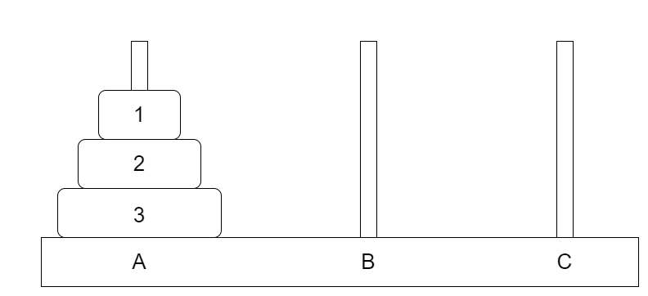

## Solution

If we have three disks on the first rod, we need a total of seven moves. The most left rod is called SOURCE, and the rightmost rod is called TARGET. The middle rod is referred to as an AUX. The AUX is needed to deposit the disk temporarily. The steps can be shown as follow.

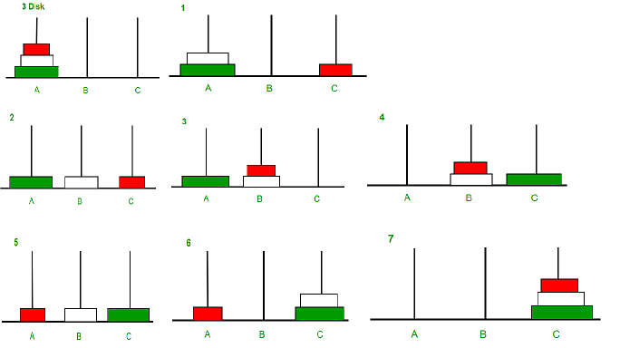

## State Space Tree

A state-space tree is a tree that we build for the solution which is starting from the root element. The root element is the initial state and one of the last element is the goal state. For the Tower of Hanoi problem, we can create a state space tree as follow.

Note: In here towers are named as A, B and C. The Disks are named as 1, 2 and 3 and initial and goal states are as follows.

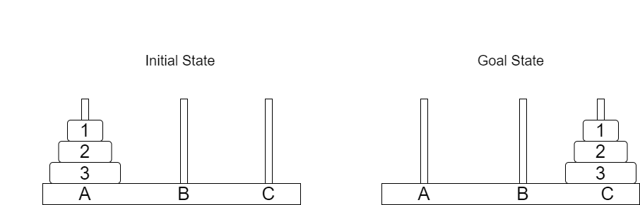

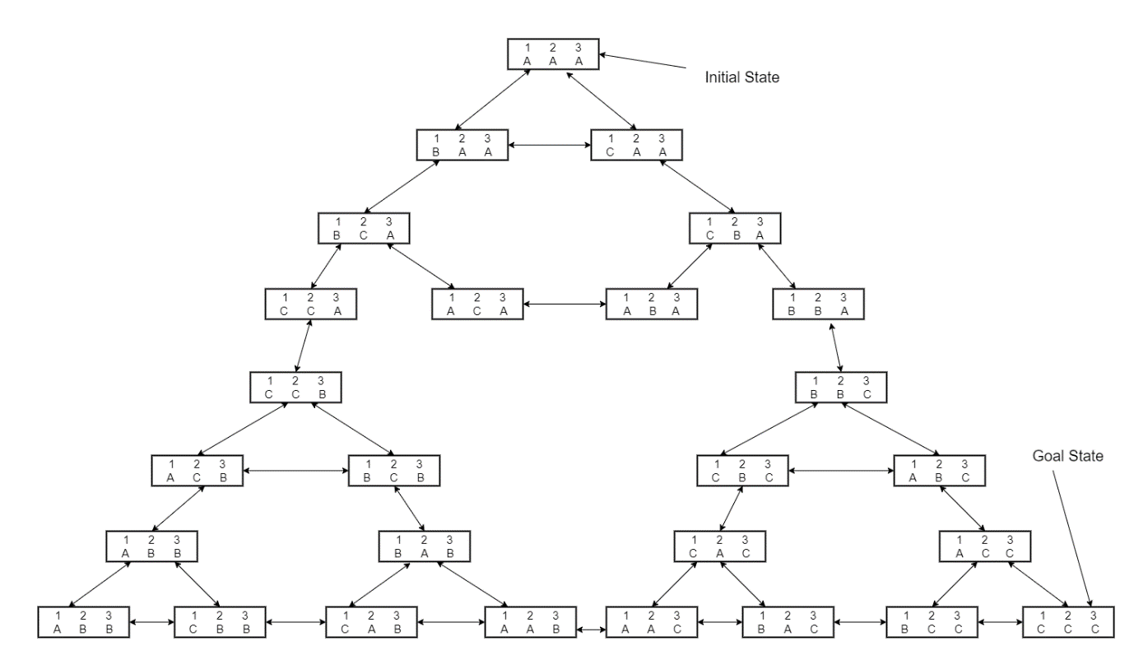The state space tree as follows.

## Find the Solution

After building a state space tree the goal state and path for the goal state can be found using two major searching methods called depth-first search and breadth-first search. Depth-first search starts at the root element and explores as far as possible along each branch before backtracking. In Breadth-first search we should start from the root element and traverse the graph layer-wise thus exploring the neighbor elements.

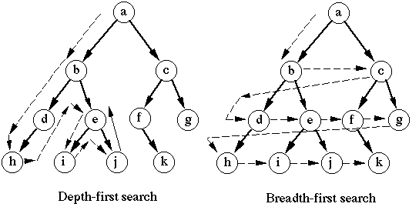

## Python Code

**File Structure**

board.py

move.py

priority.py

Breadth First Search Method

board.py

move.py

priority.py

Depth First Search Method

board.py – Consist of Board class and it includes isproblemSolved, moveDisk, hash, makeboardCopy, printBoard, successor, heuristic, towerOfHanoi, constructTargetBoard, constructBoard functions.

move.py – Consist of Search class and it includes createPath, printPath functions and bfsSearch class include search function also it includes the main function as well.

priority.py – Consist of PQ class which use to create priority queue and it includes pop function.

To run the program run the file move.py in both the scenarios.

## GIT Hub Repository link

<https://github.com/PrageethThilina/AI-ASSIGNMENT01-PYTHON>